Project Overview
This project aims to build a Space Mission Risk Analysis and Visualization Tool (SMRAV Tool) to predict potential risks for space missions based on historical mission data, environmental conditions, and equipment reliability. The goal is to showcase skills in data science, programming, front-end development, and database management, enhancing the resume for NASA applications.
Technology Stack:
- Frontend: React (for dashboard and visualization)
- Backend: Python (using FastAPI or Flask for processing data and prediction)
- Database: PostgreSQL (for storing historical mission data and predictions)
✅ Progress
Step 1: Research & Data Gathering (Current Step)
- Identify datasets related to space missions, environmental conditions, equipment reliability, etc.
- Possible sources: NASA Open Data Portal, Kaggle, ESA Data Portal, research papers.
Next Steps:
- Find suitable datasets and document them here.
- Explore data structure and identify key features to analyze.
- Prepare a database schema for storing the data.
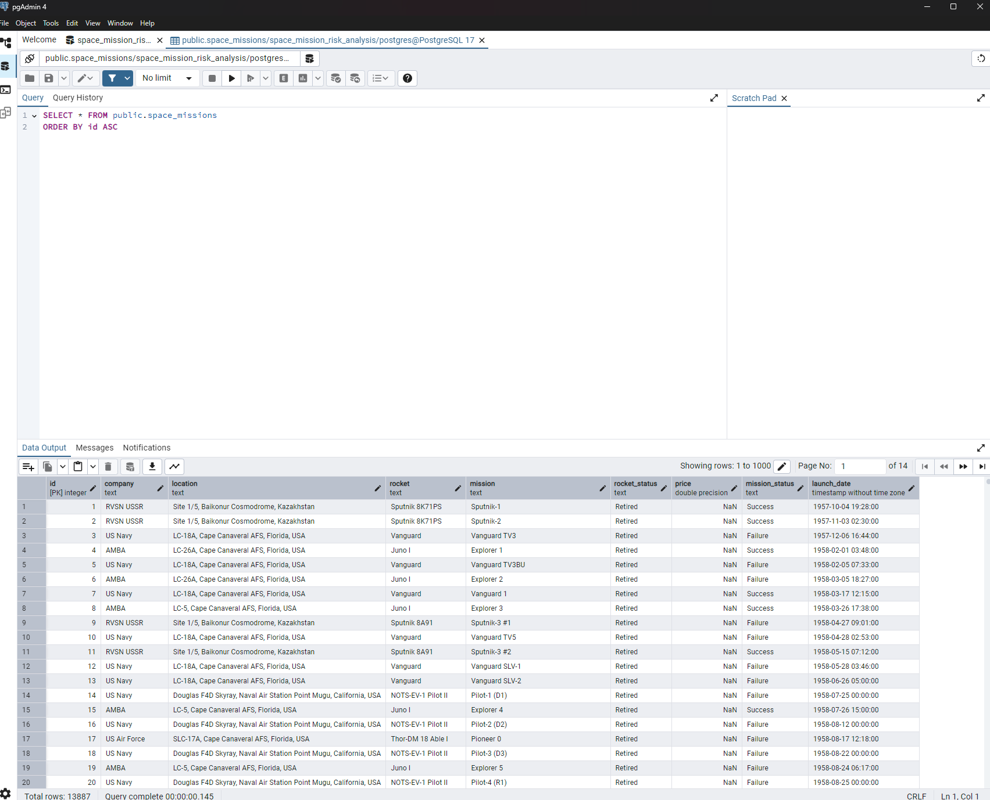
Uploaded the data into postgre from jupyter notebook. Here is an image

